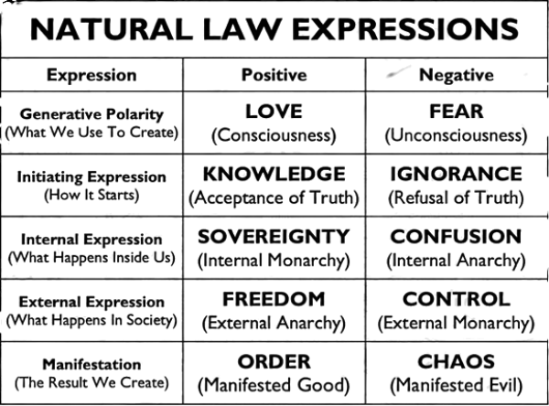

Your Name

Location Line

City, State [Zip Code]

Their Name

Location Line 1

Location Line 2

Their Name
Greetings,

I am sending this message to you personally on behalf of my moral obligation to the freedom of our country. Democide is the top cause of unnatural death and it is known as “death by government” (as in the case of World War 2), I know how to prevent this. There is nothing to sell, no political party, no corporation and no organization backing this letter. This is purely for educational purposes, sharing knowledge with you that is deliberately not taught to the public, as it is mostly only taught in occult (hidden, secret) traditions/societies. Knowledge IS power. We want freedom, yet do people know it? Can you define what is a “Right”?
Thomas Jefferson: “"Educate and inform the whole mass of the people. They are the only sure reliance for the preservation of our liberty.”
"If a nation expects to be ignorant and free, in a state of civilization, it expects what never was and never will be."

Please take the time to watch this powerful free online seminar: “Natural Law Seminar” by Mark Passio. In case reading material is preferred, please look up and read “The End Of All Evil” by Jeremey Locke. There are also 30+ year former teachers, law-enforcement, etc. in this huge free event: https://nita.one/summit. This knowledge is changing lives because we can actually determine what are our requirements for creating freedom. We want a voluntary free world for all.

If you have any questions please feel free to email me at email

By: Your Name ©

All Rights Reserved Without Prejudice

